

E-BIKE

INSTRUCTIONS

**Use Foreword**

Thank you for your purchase of this electric bicycle (e-bike). Whether you have purchased an e-bike, or regular bicycle before, please take some time to read the instruction manual carefully before operating this vehicle. If you do not feel that you can complete the assembly, or any of the routine maintenance of this e-bike, please take to your local bicycle workshop or a suitably qualified bicycle mechanic where they will be able to assist you. This manual is not intended as a comprehensive use, service, repair or maintenance manual. Please see your dealer for all service, repairs, or maintenance. Your dealer may also be able to refer you to classes, clinics or books on bicycle use, service, repair, or maintenance.

This e-Bike has an electric pedal assist drive system. In EU countries, it is legally known as PAS cycle, PAS being an acronym for “Pedal Assisted System”. The drive assist system consists of a drive unit, a battery, a controller, and various electronic components (display, harness wires, sensors, and switches). It is important to know that when the system is turned on, the drive unit engages to provide power ONLY while you are pedaling. The amount of power provided by the drive unit depends on the assistance mode/level you have set with the handlebar display control. At any time if you stop pedaling, or apply the brake/brakes, the drive

assist system will disengage. The drive assist system is also programmed to disengage if the speed limit of 25 km/h (15.5 mph) is reached, as this is a setting in the system required by law. If the speed drops below 25 km/h (15.5 mph), the drive assist system will re-engage, as long as the pedals are still turning

1. **PARTS LIST & GUIDE**

1）. Folding Electric Bicycle

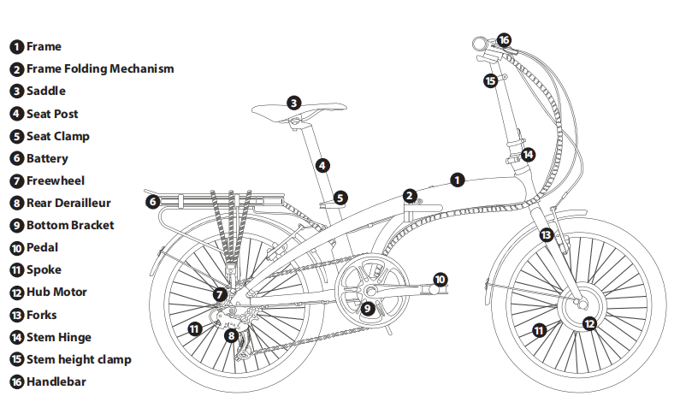

1. **Mountain** **Electric Bicycle**

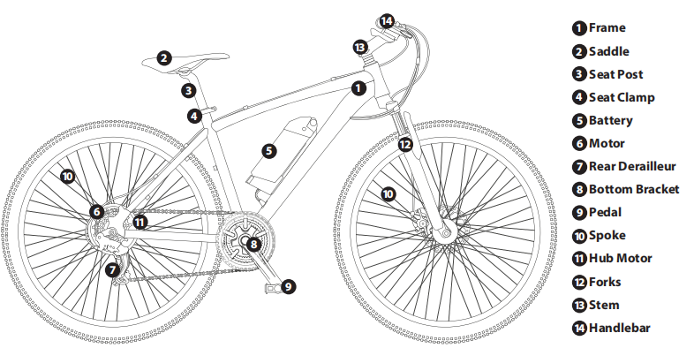

1. **GENERAL UNPACKING INSTRUCTIONS**

Remove all packaging materials (we advise that you keep these materials until you are satisfied that the e-bike is setup

correctly, and in working order). Please proceed to set all parts aside for assembly. Whether you have purchased a folding, or non-folding model, some minimal assembly will be required to prepare your e-bike for riding. Please follow the guidelines

over the next few chapters for correct assembly instructions.

Tools required include:

8mm, 10mm, 15mm and 14mm multi-spanner. 5mm & 6mm Hex (Allen) Keys.

Crosshead Screw Driver. Also, Cutters/Pliers (not included).

1. **SASAFETY FIRSTF**

Like any sport, cycling involves risk of injury and/or damage to the bicycle. By choosing to ride an electric bicycle, you

assume the responsibility for that risk, so you need to know, and to practice, the rules of safe and responsible riding, and of

proper use and maintenance. Proper use and maintenance of your electric bicycle reduces risk of injury.

This Manual contains many warnings and cautions concerning the consequences of failure to maintain or inspect your

electric bicycle, and of failure to follow safe cycling practices.

Many of the **Warnings** and **Cautions** say “you may lose control and fall”.

Because any fall can result in serious injury, or even death, we do not always repeat the warning of possible injury or death.

Because it is impossible to anticipate every situation, or condition, which can occur while riding, this manual makes no

representation about the safe use of the electric bicycle under all conditions. There are risks associated with the use of any

electric bicycle, which cannot be predicted or avoided, and which are the sole responsibility of the rider. It is important

for you to understand your new electric bicycle by reading this manual before you go out on your first ride. From this, you

will know how to get better performance, comfort, and enjoyment from your new electric bicycle. It is also recommended

that your first ride on your new electric bicycle is taken in a controlled environment, away from cars, obstacles and other

cyclists etc., to make sure you become familiar with all the controls and features of your new electric bicycle, especially the

brake performance. **If you feel anything about the electric bicycle is not as it should be, consult a qualified bicycle**

mechanic. From here on in this manual, your electric bicycle may be also be referred to as an e-bike.TY FIRST

**IMPORTANT BATTERY SLEEP MODE INSTRUCTIONS**

**Before you set your battery into SLEEP MODE, please make sure to read about SLEEP MODE preparation in**

**Chapter 7 (page 53) in this user manual.**

**Please make sure that you fully charge the battery before first use.**

**Take great care not to allow any water to get near the electric components. This includes rain, water formations**

**such as puddles, streams, rivers, potholes etc., as well as any spillages onto these components.4**

1. **HELMETS SAVE LIVES!**

Always wear a helmet! Safety gear is also available for knees, elbows, back, shoulders and more. It is highly recommended.

Protective eyeware is also recommended.

You should make sure you wear the appropriate clothing that is bright, and visible, and not too loose. Loose clothing can

catch in moving parts and cause you to lose control and fall. Be sure to dress in accordance to the weather. Your footwear

should be able to grip the pedals and not have loose laces.

Make sure you know all the local traffic laws and obey them. You are sharing the road with others and should always

assume they haven’t seen you, and exercise maximum caution on busy roads and around large vehicles.

If you are going to ride off-road, conditions may require extra attention and specific skills. Get to know your e-bike well

before trying increased speed or difficult terrain.

Be aware that in wet conditions, your brakes stopping power (and those of other road users) is greatly reduced.

If you are going to ride at night, make sure you obey all laws regarding lighting and clothing, and be aware that cyclists are

often hard to spot for drivers and pedestrians alike.

**Any form of jump, stunt, wheelies, race/competition or other extreme riding of any kind will invalidate your**

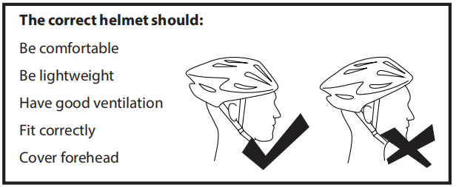**warranty.**

Always wear a cycling helmet which meets the

latest certification standards, and is appropriate

for the type of riding you do. Always follow

the helmet manufacturer’s instructions for fit,

use, and care of your helmet. A properly fitted

helmet should cover the forehead when riding

an e-bike. Most serious e-bike injuries involve

head injuries, which might have been avoided if

the rider had worn an appropriate helmet.

1. **FOLLOW THE LAWS**

It is your responsibility to familiarize yourself with the local Traffic Laws, and to comply with all applicable laws, including

properly equipping yourself, and your e-bike as the law requires. Reflectors are important safety devices which are designed

as an integral part of your e-bike. Traffic laws require every bicycle to be equipped with front, rear, front wheel, rear wheel,

and pedal reflectors. These reflectors are designed to pick up and reflect streetlights and car lights in a way that helps

you to be seen and recognized as a moving bicyclist. Check reflectors and their mounting brackets regularly to make sure

they are clean, straight, unbroken, and securely mounted. Have your dealer replace damaged reflectors and straighten or tighten any that are bent or loose.

Please ensure that if you intend to ride at nighttime, that you have fitted appropriate lights, and checked they are working properly.

**It is illegal for children under the age of 14 to ride an e-Bike.**

**IMPORTANT – PEDAL ASSEMBLY – READ FIRST**

It is your responsibility to familiarize yourself with the local Traffic Laws, and to comply with all applicable laws, including

properly equipping yourself, and your e-bike as the law requires. Reflectors are important safety devices which are designed

as an integral part of your e-bike. Traffic laws require every bicycle to be equipped with front, rear, front wheel, rear wheel,

and pedal reflectors. These reflectors are designed to pick up and reflect streetlights and car lights in a way that helps

you to be seen and recognized as a moving bicyclist. Check reflectors and their mounting brackets regularly to make sure

they are clean, straight, unbroken, and securely mounted. Have your dealer replace damaged reflectors and straighten or

tighten any that are bent or loose. Please ensure that if you intend to ride at nighttime, that you have fitted appropriate lights, and checked they are working properly.

**It is illegal for children under the age of 14 to ride an e-Bike.**

Both standard pedals and folding pedals are marked to show if they are installed on the left or on the right. **It is very**

**important to insert the correct pedal into the correct crank arm. If you don’t, you could cross thread them and cause**

**irreparable damage not covered by warranty.**

Stickers indicate the left and right pedal. If these have dropped off, look at the end of the thread where it is imprinted into the metal.

The correct pedal needs to be attached to the matching side of the e-bike crank, i.e. left pedal to left side crank, and right pedal to right side crank.

**IMPORTANT! Pedals need screwing in opposite directions, so they don’t fall off in use.**

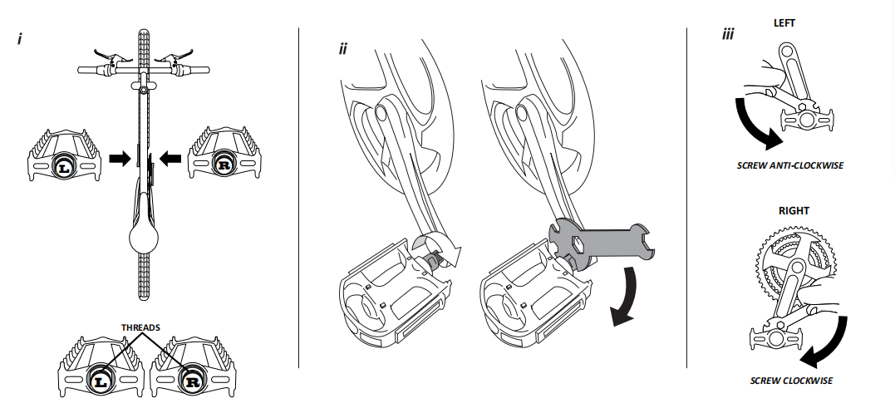Left pedal is screwed in anti-clockwise, and the right pedal is screwed in clockwise. Tighten pedals with spanner provided.

Check and re-check for tightness.

1. 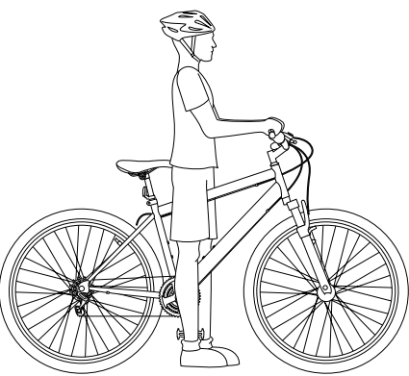**RIDING POSITIONS & GETTING STARTED**

It is important that you are able to safely get

on and off of your e-bike, and that you can

comfortably ride the e-bike, and use its features.

Please read the following guideline to help you

achieve the perfect riding position.

Stand over the bike, in front of the saddle.

Depending on what you will use your e-bike for,

you should have different levels of minimum

clearance:

For use on roads, and paved surfaces: minimum

5cm clearance.

For use on unpaved surfaces, such as canals and

towpaths: minimum 7.5cm clearance.

For heavy off-road use: minimum 10cm clearance.

For lady’s frames, you should use an imaginary

top tube, as even though you might be able to

stand over the frame, e-bikes get longer as they

get taller.

To size your e-bike, you can start at the wheel, but this is only a basic guide. You must ensure the rider can reach the

handlebars and operate the brakes, and gears (if applicable), with the elbows slightly bent.

Saddle height is adjustable, and this gives each e-bike a range of rider heights. This should be determined by the distance

from foot to pedal, NOT foot to floor. Your knee should be almost straight when the pedal is the down-most position.

Whilst you may not be able to reach the floor from this position, you may simply move forward of the saddle to mount or

dismount.

Riding is much harder with the saddle at lower adjustments than advised, as the legs will be moving in unnatural positions.

Juniors will normally prefer to be able to touch the floor from the seated position, as this will make them feel safer. This can

be adjusted as they get more confident. If the saddle is too high, and the knees lock whilst the pedal is in the downward

most position, or if the pedals cannot be reached at any point, the e-bike cannot be properly controlled, which in turn

makes the e-bike dangerous.

The saddle height can be adjusted by releasing the quick release fastener mechanism (refer to page 45 on how to release),

and sliding the seat post up or down the seat tube. Please ensure the fastener is tightened back up once the correct

position has been found.

***Please note: Under no circumstances should the seat post project from the frame beyond its “Minimum Insertion” or***

***“Minimum Extension” mark. If your seat post projects from the frame beyond these markings, the seat post or frame may***

***break, which could cause you to lose control and fall.***

To obtain maximum comfort, the rider should not overextend his or her reach when riding.

To adjust this distance, the position of the seat can be altered in relation to the seat post (refer to page 46 on how to adjust

the seat clamp). Maximum comfort is also obtained when the handlebar height is equal to the height of the seat. You may wish to try

different heights to find the most comfortable position.

***Please note: The stem’s “Minimum Insertion” mark must not be visible above the top of the headset. If the stem is extended***

***beyond this mark, the stem may break or damage the fork’s steerer tube, which could cause you to lose control and fall.***

The e-bike can be ridden with the electric assist system switched on, by connection to a lithium battery power source, or

switched off. Using the e-bike with the assist system off simply means the e-bike rides as a conventional bicycle.

As previously mentioned, the power assist drive system has a maximum speed 25 km/h (15.5 mph), and applying the

brake/brakes will cut the power to the motor.

To switch on the pedal assist system, turn the key in the battery to the on position, switch on the battery using the on/off

switch, and press the power button on the handlebar display.

Now, once you begin to pedal, and the crank is turning, you will feel the motor kick in and your electric system begin to

assist you. Whether you are using a 3, 5, 7, or 9 level module, the level of assistance can be selected by using the + and –

buttons to increase or decrease required assistance retrospectively. Please be aware that riding constantly in the high level

of assist will have a detrimental effect on the range of the battery.

Once riding, if the e-bike is fitted with conventional gears, they can be used to obtain better riding cadence and speed.

This e-bike is also fitted with a “walk assist” function. By depressing (holding down) the “6 km/h” button on the display, the

motor will engage at 6 km/h, to help you set off from a standing/sloping start, or even if you just need to help to push the

e-bike whilst you are walking. Please note, there is a slight delay from depressing (holding down) the walk assist button,

and the motor engaging. This is normal and is there as a safety feature.

Our range of e-bikes are power assisted by various batteries. An overview of these batteries are listed on pages 50-52.

Please carefully read the instructions which relate to your model/type of e-bike.

Ensure no other plug is ever connected to the main battery slot other than that supplied with your e-bike.

1. **GENERAL ASSEMBLY INSTRUCTIONS**

**6A. Folding Mechanisms: Frame, Handlebar, Pedals**

If you have purchased a folding model e-bike, please unfold the e-bike, and lock the frame hinge into place. We have

several different kinds of locking mechanisms, with instructions for use below:

**FOLDING FRAMES (where applicable)**

**Frame Folding Mechanism Type A:**

For this type of mechanism, lift the locking pin, and join the hinge tightly together. Fold the main frame hinge so that

the frame comes together at full length. Release the locking pin, so that the pin drops firmly into the hinge assembly. Lift

the quick release lever into the “V” slot (as shown), and close. Ensure that the lever is firmly locked down. This is critical to

ensure the safe operation of the bicycle. Check and re-check for tightness.

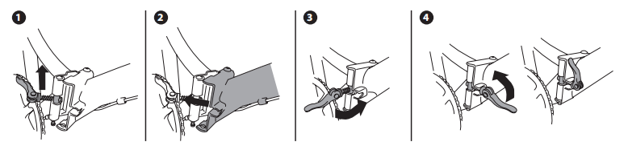

**Frame Folding Mechanism Type B:**

For this type of mechanism, make sure the moveable lever is open as shown, and fold the main frame hinge so that the

frame comes together at full length. Close the locking lever by pressing it towards the frame, and the lever should “click”

as it locks into place. Ensure that the lever is firmly locked down. Then rotate the plastic safety hook downwards into place

inside the lever. This is critical to ensure the safe operation of the bicycle. Check and re-check for tightness.

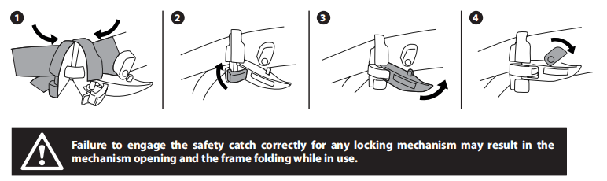**16**

**Handlebar Folding Mechanism Type C:**

For this type of folding handlebar, make sure that the locking mechanism lever is in the open position as shown. Then

swing the stem up into an upright position. Proceed to lock the mechanism lever into place, making sure the safety catch

is locked into an upright position. Check and re-check for tightness.

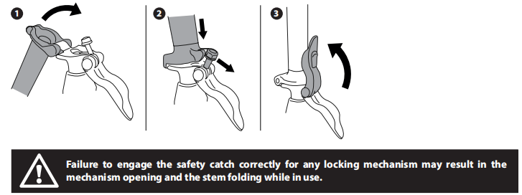

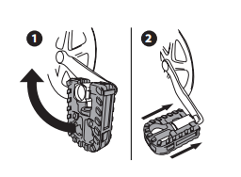

**FOLDING PEDALS (where applicable)**

**Opening the pedals:**

Your folding bike may come with one or two folding pedals. To open

these, bring the pedal to a horizontal position, 90 degrees to the

pedal arm. Keeping the pedal in this position, push it towards the

pedal arm until you hear a click.

**6B. Aligning Handlebars and Stem Assembly**

There are two different types of stem. Quill stems and ‘A’ Head (or threadless) stems. Whichever type you have, make sure

that when you install the stem/handlebar, that you don’t twist the cables. Also make sure that the front fork is facing the

correct way before tightening up the stem.

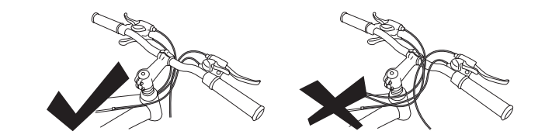**3**

**2**

**1‘A’ Head (Threadless) Stems**

This type of stem is open ended, and wraps around the steerer tube with pinch bolts, and has a top cap also.

To adjust this stem, you need to loosen the top cap, and the pinch bolts by turning the bolts anti-clockwise with an allen

key. If you are completely removing the cap to either install or change the stem, be sure to have the fork on the ground,

or, that you are holding on to it, as once you release the top cap, the fork is liable to fall through causing you to lose parts

of the headset.

Once these bolts are loose, you can adjust the stem and make sure it is in line with the front wheel.

When tightening, you should start with the top cap. Tighten it until the stem and fork are held in place, but the stem will

still rotate left to right. Then tighten the pinch bolts evenly with the stem in line with the forks (it may be easier to re-adjust

this with the front wheel fitted, so the stem is in line with it). Check and re-check for tightness.

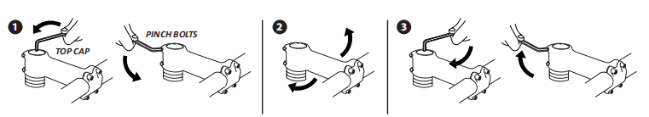

***Please Note: Stem height cannot be adjusted with this type of stem. Should you require a height adjustment, you should visit a***

***qualified bicycle mechanic for advice on different types of stems to suit your style of riding.***

To install or remove the stem/handlebar, you need to release the clamping bolts on the front of the stem (there are usually

either 2 or 4). When re-installing these clamping bolts, make sure to tighten **EACH NUT A LITTLE AT A TIME**, ensuring that

the gap between stem and clamping clamp stays even. Also take care to make sure that the handlebar is centre in the stem.

Check and re-check for tightness.

If you need to adjust the angle of the handlebar, you can do this by loosening the clamping bolts slightly, turning the

handlebar to the desired angle, ensuring it stays centred, and tightening again **EACH NUT A LITTLE AT A TIME**, ensuring

that the gap between stem and clamping clamp stays even. Check and re-check for tightness.

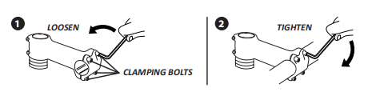**20**

**Quill (Threaded) Stems**

This type of stem has a wedge on the bottom which fits into the fork steerer tube.

To adjust or install this type of stem, you need to loosen the centre bolt enough so that the stem will fit/become loose, in

the steerer tube, by turning it anti-clockwise with an allen key.

You can then insert or adjust the stem. You can rotate it left to right and you can also adjust the height. Once your stem is

in place and in line with the forks, tighten it up by turning the centre bolt clockwise (it may be easier to re-adjust this with

the front wheel fitted, so the stem is in line with it). Check and re-check for tightness.

**Please note: The stem’s “Minimum Insertion” mark must not be visible above the top of the headset. If the stem is**

**extended beyond this mark, the stem may break or damage the fork’s steerer tube, which could cause you to lose**

**control and fall.**

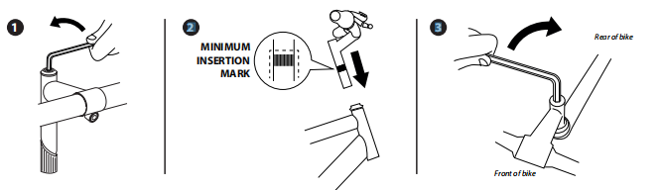**21**

**3Adjustable Angle Stems**

Some urban and trekking e-bikes may come with stems where you can adjust the angle. These can be either “A” Head

(threadless), or quill stems. In addition to the previous steps, you should set the angle and ensure the adjusting nut is tight.

Slightly loosen the adjusting nut by turning anti-clockwise using an allen key. The stem should now move up and down.

Set it to your desired angle. Tighten up by turning adjusting nut clockwise. Check and re-check for tightness.

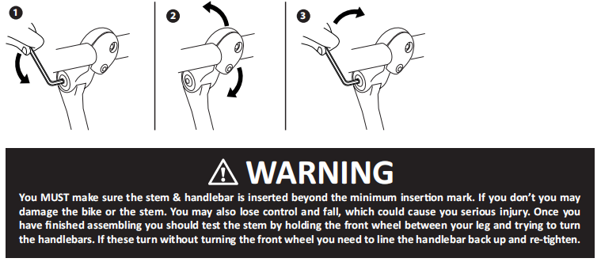

**6D. Gears**

If your bike is equipped with gears, it will have either one or two shifters. Before riding your e-bike, make sure your gears

are properly adjusted, and that you are happy with how the controls work.

The shifter fitted to the right-hand side of the handlebar controls the rear gears. These are where you have a number of

cogs on the rear wheel, and the chain is moved across them by way of a derailleur.

The LARGEST cog is the LOWEST gear, and therefore, the easiest to pedal. The SMALLEST cog is the HIGHEST gear, and

the hardest to pedal.

The shifter fitted to the left-hand side of the handlebar, if you have one, will control the front gears. These gears work the

opposite to the rear gears, and the SMALLEST cog is the LOWEST gear.

You should select a lower gear to set off, and a higher gear once you get going. Most gear shifters have a number indicator

to show which gear number you are in. Try not to leave it until you are struggling before you change gear, as this will cause

you to lose speed and control. Never change gear whilst the e-bike is not moving, or the pedals are not turning, as you

could damage your gears.

E-bikes come with the gears set from the factory, but slight adjustment may be needed before you ride the e-bike. In this

section, we will detail the different type of gear changers, and we will also explain how to make slight adjustments to

these. Gears should change easily and quietly. If they don’t, here you will find basic instructions on how to adjust them. You

will need to work out from the images which type of gears you have. There are so many brands and models of gears, it is

impossible to illustrate them all, but they all have similar functions which you will find in the following pages.

Please Note: If you are unsure, or don’t understand any of these steps, please consult a qualified bicycle mechanic. It is

recommended you have a bicycle workshop assist you with the adjustment of the gears. Cable tension must be checked

to ensure there is no slack in the cable when in the highest (fastest gear). Failure to do this will result in poor gear changes.

Lube chain and sprockets regularly with a Teflon based chain lube.

**1637906958(1)**

**Derailleurs**

Gears are usually controlled by derailleurs, which are the mechanisms that move the chain up and down the cogs. The rear

derailleur is controlled by the right-hand gear shifter, and the front derailleur by the left shifter.

**Setting Gears on a Rear Derailleur**

Turn the pedals and shift the gear on the right-hand gear shifter to the highest number/ lowest cog.

Look at the derailleur, and the cog, making sure that they are both in line. If this is not the case, then you can adjust the ‘L’ screw slightly with a crosshead screwdriver until they are. Change the shifter one position and see if the chain moves up one cog easily. Whilst changing gears, if the chain will either not change cogs, or changes two cogs at a time, you can adjust the cable tension screw.

Each derailleur model is different, so we recommend giving it half a turn one way, testing, and then adjusting accordingly until

you achieve the desired result. Now turn the pedals and change the shifter to the lowest number and largest cog.

You can now check if the chain and derailleur are in line. If it’s not, or if the derailleur has excessive play towards the wheel, adjust the ‘H’ screw slightly until they are in line with no play。

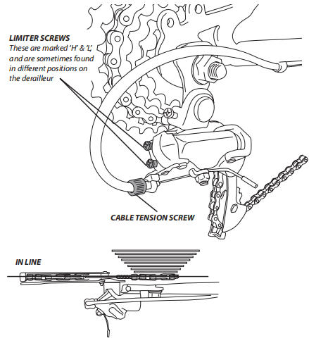 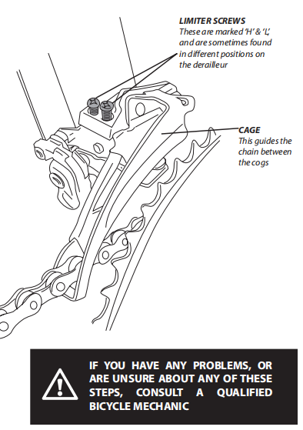

**Setting Gears on a Rear Derailleur**

1. Turn the pedals and shift the gear on the left-hand gear shifter to the lowest gear (smallest cog at the front), and the right-hand shifter to the highest gear (smallest cog at the back).
2. You should check that the chain is running freely through the cage on the front derailleur without catching. If it catches you can move the cage by slightly adjusting the ‘L’ screw.
3. Leaving the left-hand gear shifter where it is, set the right-hand shifter to the lowest gear (largest cog) and repeat step 2.
4. Change the left-hand shifter up one gear. If the gear doesn’t change smoothly onto the next cog, you can adjust the cable tension screw. For the front derailleur, this is found on the gear shifter (check which one you have in the following section). Turn slightly and keep testing until you have achieved the desired result.
5. Once the gears are changing correctly, shift the left-hand shifter on the highest gear, and check that the chain cannot clear the cage and come off the cog over the top. If it can, you can adjust it by slightly turning the ‘H’ screw with a crosshead screwdriver.

**2**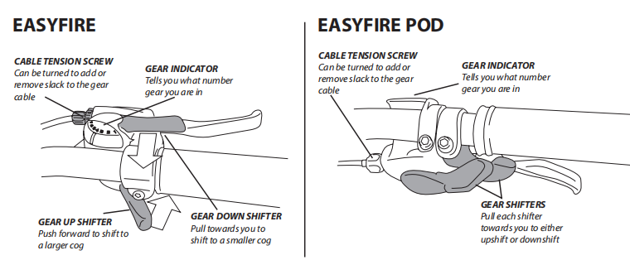

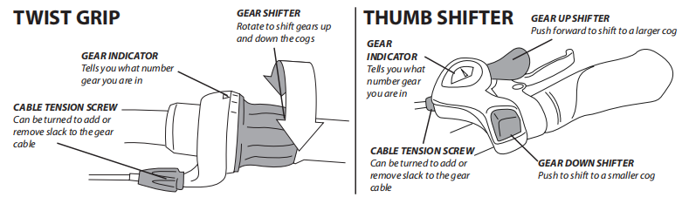

**6E. Brakes**

It’s very important for your safety that you learn, and remember, which brake lever controls which brake on your e-bike.

Traditionally, the left brake lever controls the rear brake, and the right brake lever controls the front brake. To make sure

your e-bike’s brakes are set up this way, squeeze one brake lever and look to see which brake, front or rear, engages. Now

do the same with the other brake lever.

Make sure that your hands can reach and squeeze the brake levers comfortably. If your hands are too small to operate the

levers comfortably, consult your local bike shop before riding the e-bike. The lever reach may be adjustable; or you may

need a different brake lever design.

**How Brakes Work**

The braking action of a bicycle, or an e-bike, is a function of the friction between the braking surfaces. To make sure that

you have maximum friction available, keep your wheel rims and brake pads free of dirt, lubricants, waxes or polishes.

Brakes are designed to control your speed, not just to stop the bike. Maximum braking force for each wheel occurs at the

point just before the wheel “locks up” (stops rotating), and starts to skid. Once the tyre skids, you actually lose most of

your stopping force, and all directional control. You need to practice slowing and stopping smoothly without locking up

a wheel.

This technique is called progressive brake modulation. Instead of jerking the brake lever to the position where you think

you’ll generate the appropriate braking force, squeeze the lever progressively, increasing the braking force.

If you feel the wheel begin to lock up, release the pressure just a little to keep the wheel rotating just short of lockup. It’s

important to develop a feel for the amount of brake lever pressure required for each wheel at different speeds, and on

different surfaces. To better understand this, experiment a little by walking your e-bike and applying different amounts of

pressure to each brake lever, until the wheel locks.

When you apply one, or both brakes, the bike begins to slow, but your body wants to continue at the speed at which it was

going. This causes a transfer of weight to the front wheel, or under heavy braking, around the front wheel hub, which could

send you flying over the handlebars.

A wheel with more weight on it will accept greater brake pressure before lockup; a wheel with less weight will lock up with

less brake pressure. So, as you apply brakes and your weight is transferred forward, you need to shift your body toward the

rear of the bike, to transfer weight back on to the rear wheel; and at the same time, you need to both decrease rear braking

and increase front braking force. This is even more important on descents, because descents shift weight forward.

Two keys to effective speed control and safe stopping are controlling wheel lockup and weight transfer. This weight transfer

is even more pronounced if your e-bike has a front suspension fork. Front suspension “dips” under braking, increasing the

weight transfer. Practice braking and weight transfer techniques where there is no traffic or other hazards and distractions.

Everything changes when you ride on loose surfaces or in wet weather. It will take longer to stop on loose surfaces or in

wet weather. Tire adhesion is reduced, so the wheels have less cornering and braking traction, and can lock up with less

brake force. Moisture or dirt on the brake pads reduces their ability to grip. The way to maintain control on loose or wet

surfaces is to go more slowly.

Brakes are a very important part of your e-bike, and you need to familiarize yourself with which type of brake you have.

This part of the manual will cover all types. If you need any slight adjustment to the brakes, try using the barrel adjuster on

the levers first (see V Brakes or Expansion Brakes section). **We always advise that if you are unsure about anything to**

**do with your brakes or their functions, you should consult a qualified bicycle mechanic before riding your e-bike.**

**1637907723(1)Rim Brakes**

Rim brakes work by squeezing brake pads (usually made from rubber) against the rim, in order to slow the wheel down. It

is important that you **keep them serviced.** You may need to adjust your brakes, and you may need to release and engage

them in order to replace a wheel. In this manual you will find a guide on how to do this, however, **if you are unsure about**

**anything to do with your brakes or their functions, you should consult a qualified bicycle mechanic before riding**

**your e-bike.**

You should regularly check these points and adjust accordingly (these rules do not apply for disc brakes). If you are unsure,

consult a qualified bicycle mechanic:

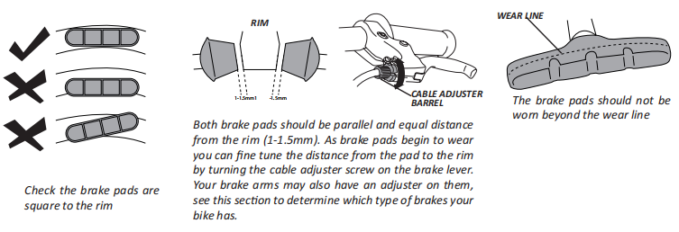**8**

**IMPORTANT**

**Both brake arms should move the same distance when you squeeze the brake lever.**

**The rim should run freely through the brake pads with no contact when the brake is open.**

**The brake pads should touch the rim before the brake lever is 1/3 of the way to the handlebar.**

**Keep your brakes serviced regularly.**

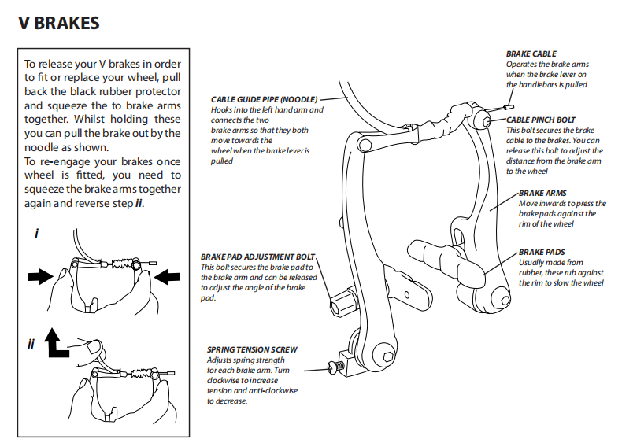

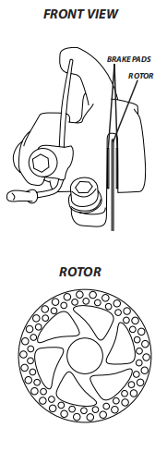**DISC BRAKES**

Disc brakes work by squeezing brake pads against a disc in order to slow the wheel down. It

is important that you **keep these serviced.** You may need to adjust these brakes from time

to time. **If you are unsure about anything to do with your brakes or their functions, you**

**should consult a qualified bicycle mechanic before riding your e-bike.**

**IMPORTANT:**

**The wheel should run freely through the brake with no contact with the brake pads**

**when the brake is open.**

**The disc should be centered in the slot between the brake pads as shown.**

**Worn brake pads should be replaced immediately.**

**The brake pads should touch the rotor before the brake lever is 1/3 of the way to the**

**handlebar.**

**Keep your brakes serviced regularly.**

Be aware that disc brakes will get hot after use. You could severely injure yourself through

contact with a hot disc, so mind your legs as well as your hands! They also have sharp parts.

If you make contact with any part of the brakes whilst the wheel is turning, you could also

injure yourself.

Before you first ride your e-bike with disc brakes, give them a clean using rubbing alcohol.

**NEVER USE OIL TO CLEAN YOUR DISC BRAKES.** Your first ride performance with disc

brakes may be less than perfect. We recommend riding the bike gently for around 13 - 15

miles to break the disc brakes in before riding down hills/slopes etc.

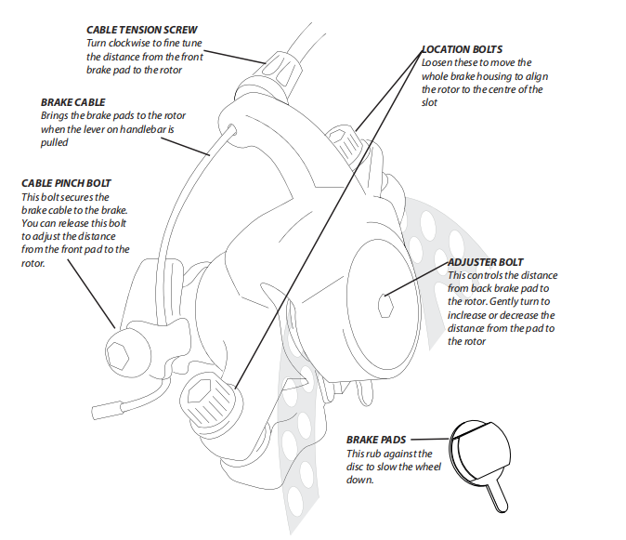

**6F. Wheels, Tyres & Inner Tubes**

The wheel axles are inserted into slots, called “dropouts”, in the fork and frame. Examples below:

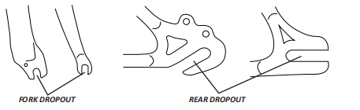

Dropouts come in way too many different shapes and sizes to be able to illustrate them all here, but these examples should

guide you to identifying where your dropouts are.

There are two types of wheel fastening systems, and your bike may have one or another, or in some cases one of each. It is

important that you know which type of system/s your bicycle is equipped with, and that you understand how this work.

**Quick Release Hubs & how do they work?**

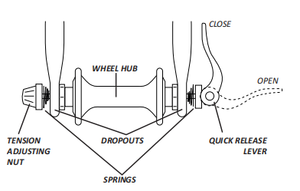The wheel hub is clamped in place by the force of the quick

release lever pushing against one dropout, and pulling the

tension adjusting nut against the other dropout. The amount

of clamping force is controlled by the tension adjusting nut.

Turning the tension adjusting nut clockwise while keeping

the cam lever from rotating and increases clamping force.

Turning it anti-clockwise, while keeping the cam lever from

rotating, reduces clamping force. Less than half a turn of

the tension adjusting nut can make the difference between

safe clamping force and unsafe clamping force. You should

tighten the tension adjusting nut until it is finger tight

before closing the quick release lever.

**Installing and adjusting a front wheel with a quick release system**

If your bike comes with a quick release front wheel, this will usually come separate to the wheel, and will look something

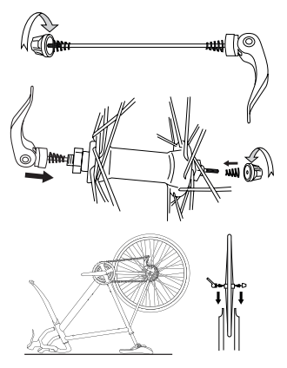like the picture below.

1. You need to remove the tension adjusting nut,

and one spring from the skewer, by turning it anti

clockwise.

1. You should then insert the skewer through the

wheel axle, put the spring back in place, always

with the narrow end of the spring facing the wheel,

and screw the tension adjusting nut back on very

loosely. Just a couple of turns should do.

1. For this step, if your saddle and handlebar are installed, it helps to turn the bike upside

down. You should then insert the wheel into the

dropouts as shown, ensuring that the springs are

to the outside of the dropout. The quick release

lever should be on the opposite side to the chain

side. You may need to release the brakes to get

the wheel through. If this is the case, go to the

brakes section of this manual where you will find

instructions on how to do this.

1. 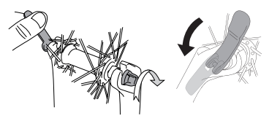Once the wheel is in place in the dropouts, hold the quick release lever in the open position, and turn the tension adjusting nut in a clockwise direction until it is finger tight. Once it is finger tight, move the quick release lever to the closed position, so that it is parallel with the fork。

**Please Note: With a quick release lever, to apply enough clamping force, you should have to wrap your fingers**

**around the bicycle frame for leverage, and the lever should leave a clear imprint in the palm of your hand. If this is**

**not the case, open the quick release lever, turn the tension adjusting nut a quarter turn, and close the lever again.**

**Keep doing this until tight enough.**

Should you need to remove your wheel, to replace it or to repair it, simply reverse these steps.

1637909994(1)

**Removing or adjusting a rear wheel with a quick release system**

This step is easier with the bike upside down, resting on the saddle and the handlebars. For that purpose, the images here

show what these steps look like with the bike upside down.

1. Should your bike have gears, shift the rear derailleur to high gear (the smallest, outermost rear sprocket).
2. You may also need to release the brakes to get enough clearance for the wheel to pass through. Should this be the case, see the brakes section in this manual for instructions on how to do this.
3. Open the quick release lever, then push the wheel forward far enough to be able to remove the chain from the rear sprocket.
4. Should your bike have gears, pull the derailleur body back with your right hand to release the tension on the chain and hold it there for the next step.
5. You can now remove the wheel out of the dropouts.

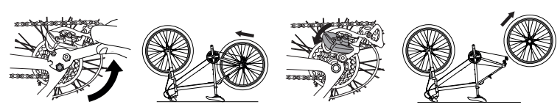

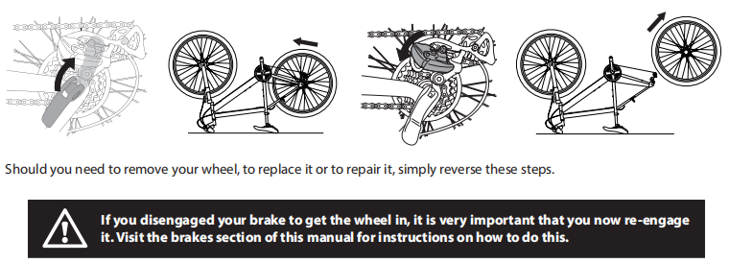

**3**

**4**

**Tire inflation and how to change a tube?**

Bicycle tires come in many designs and specifications for different types of riding. They range from general purpose tires,

to specific tires for different weather/terrain. Always ensure tires have enough tread, and have no bulges or excessive

wear.

Once you get some riding experience on your new e-bike, you may feel that a different type of tire may suit your needs

better. Any bicycle shop will be able to help you chose the correct type of tire for your style of riding.

All tires have the pressure ratings on the sidewall, as well as other bits of information, such as size, and occasionally

intended use.

It is very important that you never inflate a tire beyond the maximum pressure marked on the sidewall. This could cause

it to burst and blow off the rim, which could cause serious injury to both yourself and/or bystanders and pedestrians.

I**t is also not recommended to use garage forecourt or any other type of compressor to pump up your tyres,** as these

dispense a very large amount of air very quickly, which can cause your tube/tire to explode. Always inflate Tires to the

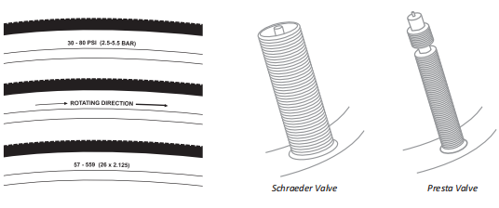correct PSI (pressure) as specified on side of the tire, and maintain by checking once per week. Correct tire pressure is

critical to the performance of the bike.

There are mainly 2 types of valves on e-bikes, the Schrader valve, which is similar to a car tire, and the Presta valve, which

is much thinner. You will need to have the correct pump fitting for the type of valve on your e-bike.

**5**

**Mudguard installation (if applicable)**

Your e-bike may have come equipped with mudguards, especially if a trekking or heritage model. If this is the case, the front mudguard will usually come separate in the box and will need fitting.

**Rear Carrier Information (if applicable)**

Your e-bike may be installed with a rear carrier. **Please Note: Maximum weight to be loaded onto the rear carrier is 25Kgs. The rear carrier is NOT intended for passenger use.**

1. First, remove the nut from the bolt in the top of the fork using the spanner provided, leaving the bolt in place through the fork. Then remove the two screws from the feet of the fork using a crosshead screwdriver.
2. You can then locate the mudguard in place. First feed the mudguard through the back of the fork as shown. Locate the mudguard on the bolt you left in the fork as shown and screw the nut on clockwise until it is finger tight. You can then screw the mudguard to the feet of the fork by replacing screws through the mudguard brackets and into the fork, tightening them by turning clockwise with a crosshead screwdriver. Tighten the nut on the top of the fork, turning clockwise using the spanner provided。

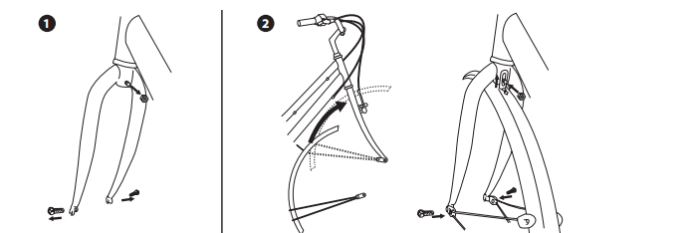

1. **BATTERY INFORMATION & DISTANCE RANGE**

Your battery will be packed partially charged. We strongly advise that you give the battery a full charge first before use.

This will help maintain the life of the battery. For optimal battery performance, complete three full discharge and three

complete recharge cycles. If the e-bike is not to be used for a long period, it is suggested to close the power of battery pack,

and charge-discharge the battery once one month (unless your battery has sleep mode function, ask your dealer if unsure).

The battery is turned on by using the switch located on the battery casing. Power indication lights are used in the battery

shell, and on the handlebar display. On the battery shell, green LED lights indicate battery life, red lights indicate that the

battery is almost empty and needs charging. The handlebar display generally uses only red LED lights, with a full battery

showing all lights lit, and an empty battery showing just one light lit. **Please ensure that only the charger supplied is**

**used to charge the battery.**

To prevent the battery from working loose, ensure that the battery is locked into position with the keys provided. When

you are operating around the battery, do not insert metal objects (such as lead wire, key etc.) into the charging socket, or put

them on the positive and negative contact points of battery cell, as this will cause the battery to short-circuit, or endanger

your own personal safety, including risk of fire.

**Please note: Any figures quoted for battery performance, or distance, that can be obtained from a single charge,**

**are based on standard test/riding/rider conditions. Diverse terrain, and/or rider weight, will of course produce**

**varying results from those stated.**

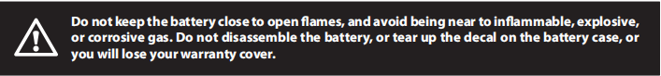

**Our Battery Styles**

There are many battery styles and it would be impossible to list them all, but the following diagrams should help you

familiarise yourself with your battery and it’s different functions.

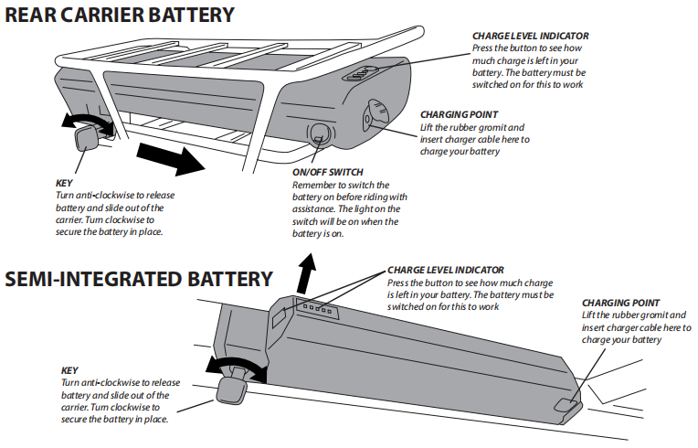

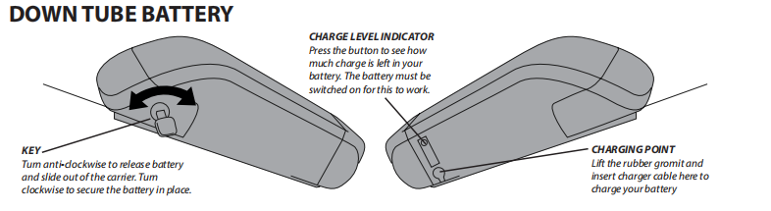

**Sleep Mode Function**

Should your battery be fitted with a sleep mode function (check with your dealer), your battery is fitted with a smart Battery

Management System (BMS). This allows the battery to hibernate for up to 6 months without charge. We recommend you

use this function only if necessary. Please make sure that the battery is stored in dry, room temperature conditions. **Make**

**sure your battery is at 50% charge BEFORE letting it hibernate for long periods of time.**

**Frequently Asked Battery Questions**

**Q: Do I need to charge the battery before using it?**

*A: Yes, you should charge the battery fully before first use of it.*

**Q: Do I need to “brake-in” my battery?**

*A: Yes, the battery will need to have a “break-in” cycle consisting of three discharge/charge cycles before they will reach*

*optimum performance. This involves three complete discharge and three complete recharges. After this initial “break-in” cycle,*

*the batteries will have maximum possible performance, and less line voltage fluctuations under load.*

**Q: How long will the battery hold its charge?**

*A: All batteries will self-discharge when not in use. The self-discharging rate depends on the temperature at which batteries are stored. Always store a battery at room temperature.*

**Q: If my battery does not have a sleep mode function, why should I recharge my Lithium-Ion battery at least every 90 days when I’m not using them?**

*A: Batteries naturally lose their charge over time. To keep the batteries in optimal condition, and extend their life, it’s*

*recommended that a top-off recharge be performed at least every 90 days.*

**Q: What happens if leave the power switch on longer the 5 minutes?**

*A: If you have left the power switch on, or your product has not been charged for a long period of time, the battery may reach a stage at which it will no longer hold a charge.*

**Q: Will I get more performance from my e-bike if I leave the batteries to charge longer?**

*A: No, once the battery is fully charged (as indicated by the light on the charger), it is best to unplug them from the charge*

*(Even if your e-bike is fitted with a smart charger with auto cut-off). Leaving the batteries charging longer than necessary is called “overcharging” and will not increase performance. Most chargers are designed to avoid over-charging a battery, but we still recommend that you always unplug a charger after the unit is fully charged to avoid the possibility of unanticipated circumstances, such as an unexpected power surge from a lighting strike, or other power line anomalies potentially causing damage. Please ensure that only the charger supplied is used to charge the battery.*

**Q: Is it normal that the battery gets warm when recharging?**

*A: Yes, it is normal that the battery will become warm to the touch during the recharging process. This is because the increase of internal resistance, and less energy conversion efficiency from electric energy to chemical energy.*

**Q: How long will my batteries last before needing replacement?**

*A: Average battery life depends on use and conditions. Even with proper care, rechargeable batteries do not last forever.*

**How to maximize the distance range of your e-bike**

**Rider Input** - The more the rider pedals, the further the distance traveled. Continuous riding, as opposed to frequent

stopping and starting, will yield the greatest range possible.

**Elevation Gain** - The flatter the road, the further the distance traveled.

**Weather** - Cold weather can adversely affect the battery capacity. Traveling with a tailwind will also increase distance

traveled, whereas traveling into a headwind will decrease the distance traveled.

**Terrain** – The smoother the terrain (tarmac roadways etc.), the further the distance.

**Rider & Load Weight** - The lighter the rider, the less drain on the battery, and therefore the further the distance. The

standard load weight of this e-bike is 75Kg (including the cyclist). Overloading may cause the travel mileage to decrease,

or cause the parts and components of whole e-bike problems, resulting in damage, and reduced working life of the

battery.

**E-Bike Maintenance** - A properly maintained e-bike will yield the greatest possible distance. This includes properly

inflated tyres, which will have less rolling resistance, and will be easier to pedal.

**The Battery** - Properly changed and maintained batteries will yield the greatest range possible. Batteries stored in cold

areas (below 50 degrees Fahrenheit/10 degrees Celsius) will show reduced range. Never allow batteries to freeze (below 32

degrees Fahrenheit), as this will result in permanent damage to them.

**Braking** - Frequent braking, or stop/starting, will consume larger electricity, thus influencing the travel mileage. Try to

decrease the frequency of braking and starting as is safe.

1. **BATTERY CHARGING**

Develop a habit of charging regularly. When the power of the battery pack shows a red light, please charge to maintain

the battery pack to have a longer service. If the e-bike is not to be used for a long period, it is suggested to close the

power of battery pack, and charge-discharge the battery once one month (unless your battery has sleep mode function,

ask your dealer if unsure). **Ensure only the charger supplied is used to charge the battery. Make sure battery is set to**

**“off” before charging, and plug the charger into the electric socket first, before connecting to the battery.**

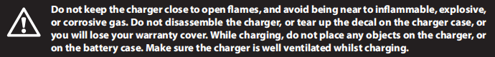

**Battery fault fire or explosion hazard will occur if the instructions are not followed:**

Ensure that the charger plugs are dry and securely connected to the charger port of battery case.

Do not cover the battery or charger while charging, do not use the battery charger near flammable articles or in

unventilated places. The ambient temperature should not exceed 40°C.

Keep the battery and charger away from water, to prevent shocks or shorting.

Only use the charger provided to charge the battery.

Do not disassemble or modify the battery or charger.

Do not expose the battery or charger to fire or extreme temperatures.

Do not drop or allow impact or force against the battery pack or charger.

Pull out the power plug first, and then the charger plugs after charging. Connecting the power plug and the power

source for a long time while not charging is not recommended.

Should any abnormal conditions occur, like overheating or peculiar smells, stop charging immediately and contact

your authorized dealer for help.

Put the battery and charger in a safe place beyond children’s reach.

If you are commuting significant distances, it is advisable to recharge the battery before the return journey.

For occasional use, discharge and recharge the battery at least once a month, even if the cycle is unused.

Always recharge the battery after use. Remember that charging the e-bike after every use will ensure longer life of the

battery.

The manufacturer will not be responsible for any damage or injury due to improper or unsafe use of the battery

charger.

Check the AC voltage is set to 220/240v. Never use on 110v setting

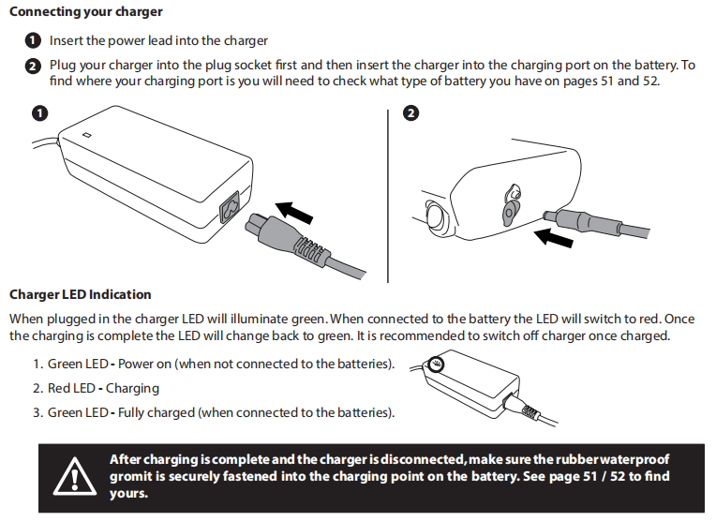

1. **DISPLAYS & BLUETOOTH FUNCTIONS**

The LCD display is located on the handlebars of the e-bike. To switch the display on, simply press the power button.

To switch the display off, press and hold down the power button.

To change the level of assistance, you can press either the MODE button, or the +/- buttons, depending on the model of

the display. Insert images

This e-bike is also fitted with a “walk assist” function. By depressing (holding down) the “6 km/h” button on the display, the

motor will engage at 6 km/h, to help you set off from a standing/sloping start, or even if you just need to help to push the

e-bike whilst you are walking. Please note, there is a slight delay from depressing (holding down) the walk assist button,

and the motor engaging. This is normal and is there as a safety feature.

**Bluetooth Function**

If your e-bike has a controller capable of Bluetooth function (if unsure ask your dealer), then you can download the

relevant mobile phone APP to use with your e-bike.

Download the relevant APP via your relevant APP store, switch on the Bluetooth facility on your mobile phone, and

connect to the controller. Further details of the relevant APP will be added separately to this manual if applicable to your

model.

1. **FINAL INSPECTION - BEFORE YOU RIDE**

We strongly urge you to read this Manual in its entirety before your first ride. At the very least, read and make sure that

you understand each point in this section and refer to the cited sections on any issue which you don’t completely understand.

Ensure you have assembled the e-bike and fitted all loose parts that came in the box.

Check the chain is lubricated.

Make sure all wheel fixings are tight and fitted correctly.

Check trueness of wheels and the tire pressures.

Make sure your saddle is at the correct riding height/position, and not beyond the “minimum insertion mark”. Check

that all fixings are tight.

Make sure you have adjusted the handlebar height and angle (where applicable) to your riding position, and that it is

not beyond the “minimum insertion mark”. Check all nuts are tight.

Any extras or accessories must be correctly fitted and tight.

Check brake functionality. Adjust if necessary. Right hand lever should operate the front brake, and left hand lever

should operate the rear brake. Make sure you can reach the brake levers and operate the brakes comfortably from

your riding position.

Make sure your gears change cleanly, and that you can operate the gear levers comfortably from your riding position.

Check that all chainwheel and crank bolts are tight.

1. **MAINTENANCE**

The following procedures will help you maintain your e-bike for years of enjoyable riding.

Do not ride your e-bike in water (damp roads, puddles, rain, streams etc.), and never immerse it in water as the electrical

system will incur damage. Store your e-bike under shelter, and avoid leaving it in the rain, or exposed to corrosive

materials. Riding on the beach, or in coastal areas, exposes your e-bike to salt, which is very corrosive. Wash your e-bike

frequently, and wipe or spray all unpainted parts with an anti-rust treatment. Make sure wheel rims are dry, so braking

performance is not affected. After rain, dry your e-bike and apply anti-rust treatment. If paint has become scratched or

chipped to the metal, use touch up paint to prevent rust. Clear nail polish can also be used as a preventative measure.

**Cleaning & Lubrication**

It is important in order to keep your bike in good and safe working order to make sure it is clean and lubricated. Always

wash off any excess dirt and dry well, before lubricating moving parts. Below is a guide that may help you with your

maintenance schedule, but this will depend on how and where you ride, and also on how often you ride.

Do not over lubricate, and ALWAYS wipe off any excess lubrication, especially if you get it on the brakes, brake pads or

rims, as this may decrease brake functionality, and increase stopping distances. If you have any doubts about any of these

parts, please consult a qualified bicycle mechanic.

**Break-in Period**

Your e-bike will last longer and work better if you break it in before riding it hard. Control cables and wheel spokes may

stretch, or “seat”, when a new e-bike is first used, and may require readjustment. This manual will help you identify some

things that need readjustment. But even if everything seems fine to you, it is often best to take your e-bike to your local

mechanic for a checkup. Dealers typically suggest you bring the e-bike in for a 30-day checkup. Another way to judge

when it’s time for the first checkup is to take the e-bike in after three to five hours of hard off-road use, or about 10 to

15 hours of on-road, or more casual off-road use. But if you think something is wrong with the e-bike, take it to your

mechanic before riding it again.

Before every ride: See Chapter 10 – Final inspection before you ride

After every long or hard ride, if the e-bike has been exposed to water or grit (or at least every 100 miles), clean the e-bike,

and lightly lubricate the chain’s rollers with a good quality bicycle chain lubricant. Wipe off excess lubricant with a lint free

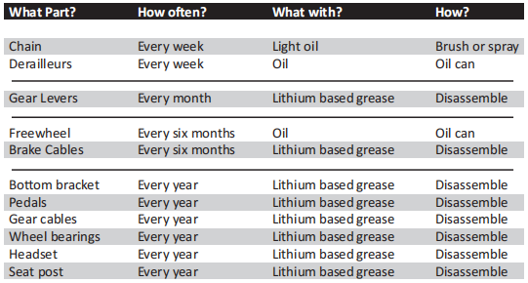cloth. Lubrication is a function of climate. Talk to your local mechanic about the best lubricants and the recommended

lubrication frequency for your area. (See below for help with lubrication areas). Do not over lubricate, and ALWAYS

wipe off any excess lubrication, especially if you get it on the brakes, brake pads or rims, as this may decrease brake

functionality, and increase stopping distances. If you have any doubts about any of these parts, please consult a qualified bicycle mechanic.

**After every long or hard ride, or after every 10 to 20 hours of riding, check the following:**

**As required:**

Squeeze the front brake and rock the bike forward and back. Everything feel solid? If you feel a clunk with each

forward or backward movement of the bike, you probably have a loose headset.

Lift the front wheel off the ground and swing it from side to side. Feel smooth? If you feel any binding or roughness in

the steering, you may have a tight headset.

Grab one pedal and rock it toward and away from the centerline of the bike. Then do the same with the other pedal.

Anything feel loose? If so, have a qualified bicycle mechanic check it.

Look at the brake pads. Starting to look worn or not hitting the wheel rim squarely? They may need adjusting or

repairing, see the brakes section of this manual.

Carefully check the control cables and cable housings. Any rust? Kinks? Fraying? If so, have a qualified bicycle

mechanic replace them.

Squeeze each adjoining pair of spokes on either side of each wheel between your thumb and index finger. Do they all

feel about the same? If any feel loose, have the wheel checked for tension and trueness.

Check the tires for excess wear, cuts or bruises.

Check the wheel rims for excess wear, dings, dents and scratches. If present, ask a qualified bicycle mechanic if they

need replacing.

Check to make sure that all parts and accessories are still secure and tighten any which are not.

Check the frame (particularly in the area around all tube joints), handlebars, stem, and the seat post for any deep

scratches, cracks, or discoloration. These are signs of stress-caused fatigue, and indicate that a part is at the end of its

useful life and needs to be replaced

**As required:**

If either brake fails, don’t ride the e-bike. Have your local bicycle mechanic check the brakes.

If the chain won’t shift smoothly and quietly from gear to gear, the derailleur is out of adjustment, take it to a qualified

bicycle mechanic.

It is recommended that every 25 (hard off-road) to 50 (on-road) hours of riding, take your e-bike to a qualified bicycle

mechanic for a complete checkup.

**6 Week Inspection**

It is recommended that after this period you should inspect your e-bike, as things will slacken off and need re-tightening.

**Every 6 Months**

It is recommended that every 6 months you complete a full service on your e-Bike to keep it in excellent working

condition.

Periodically check the wiring and connectors to ensure there is no damage, and that the connectors have good continuity.

**Caring for your Battery**

Properly maintain the batteries by keeping them fully charged when not in use. When stored and not in use, please

remove the battery and store in a cool dry place, charging periodically, if your battery is not fitted with SLEEP MODE

function, as the battery will discharge over time of none use. It is recommended that the battery is charged AT LEAST once

a month while it is not being used.

**Failure to do this will result in the battery falling into a dormant state, rendering the battery unrepairable.**

***Please Note: It is ok to oil the chain and front or rear axle (depending on if you have front or rear hub motor), but THE MOTOR SHOULD NOT BE LUBRICATED.***

**If you have an accident**

First, check yourself for injuries, and take care of them as best you can. Seek medical help if necessary.

Next, check your e-bike for damage. After any crash, take your bike to your local mechanic for a thorough check. Carbon

composite components, including fames, wheels, handlebars, stems, crank sets, brakes, etc., which have sustained an

impact must not be ridden, until they have been disassembled, and thoroughly inspected by a qualified mechanic.

1. **TROUBLESHOOTING**

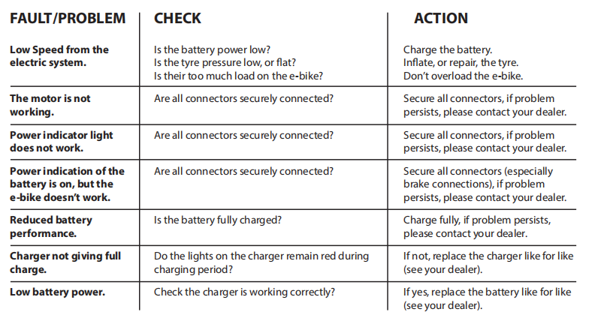

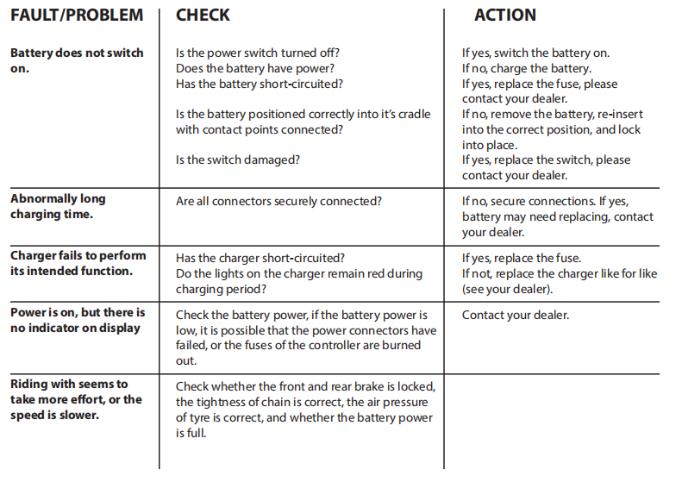

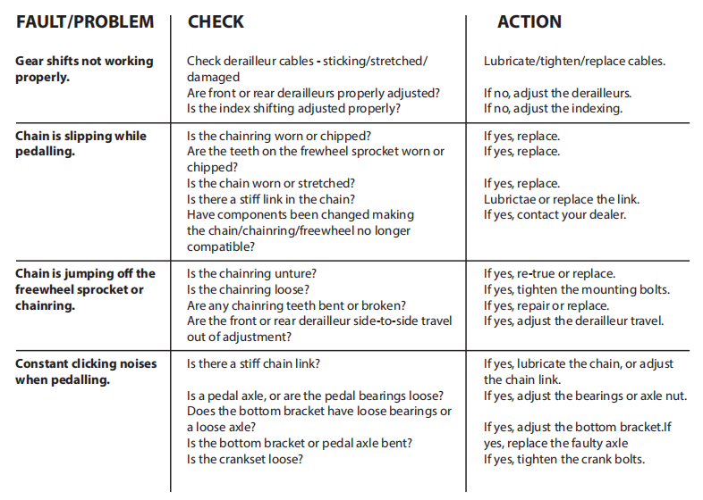

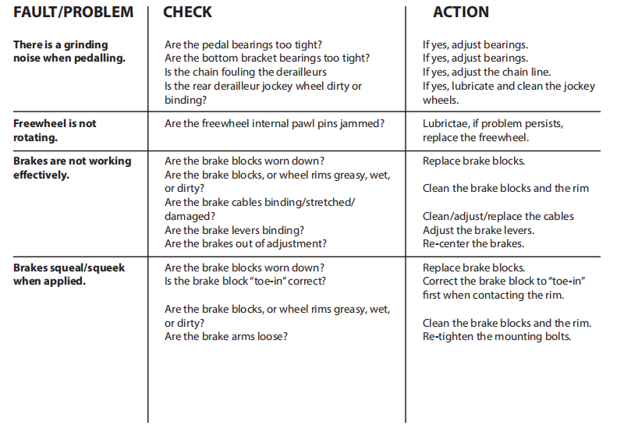

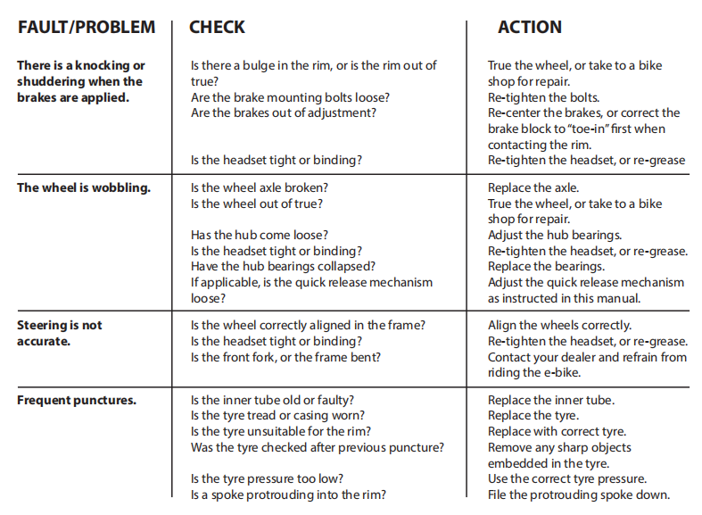

Other faults that can’t be solved, or for motor, controller, charger, battery failure - please contact your authorised dealer

for help. Any changes to these parts will invalid your warranty. If unsure on any of these points, or you fail to correct the

problem, we would advise you to seek assistance from your local e-Bike specialist.

1. **RIDING SAFELY**

When riding, obey the same road laws as all other road vehicles, including giving way to pedestrians, and stopping at red

lights and stop signs. Ride predictably, and in a straight line. Never ride against traffic. Use correct hand signals to indicate

turning or stopping, and ride defensively. Be aware, to other road users, you may be hard to see. Concentrate on the path

ahead, and avoid potholes, gravel, wet road markings, oil, curbs, speed bumps, drain grates and other obstacles. Cross train

tracks at a 90-degree angles or walk your e-bike across. Expect the unexpected, such as, opening car doors, or cars backing

out of concealed driveways.

Familiarize yourself with all the e-bike’s features. Practice gear shifting, braking, and the use of toe clips and straps (if fitted).

If you are wearing loose pants, use leg clips or elastic bands to prevent them from being caught in the chain or gears. Wear

proper riding attire and avoid wearing open toe shoes.

Don’t carry packages, or passengers, that will interfere with your visibility or control of the e-bike. Don’t use items that may

restrict your hearing.

Do not lock up the brakes when braking. Always apply the rear brake first, then the front. The front brake is more powerful,

and if it is not correctly applied, you may lose control and fall.

Maintain a comfortable stopping distance from all other riders, vehicles, and objects. Safe braking distances, and forces, are

subject to the prevailing weather conditions.

**IT IS NOT RECOMMENDED TO RIDE IN WET WEATHER**

This e-bike is not meant for use in wet conditions (damp roads, puddles, rain, streams, etc.) Never immerse this product in

water as the electrical system may be damaged.

Should you find yourself in a situation of wet weather, remember to take extra care. Stopping distances will take up to

6 times further, so be aware to brake earlier. Decrease your riding speed, avoid sudden braking, and take corners with

additional caution. Be more visible on the road, wear reflective clothing and use safety lights. Potholes and slippery surfaces,

such as line markings and train tracks, all become more hazardous, and more difficult to see, when wet.

**IT IS NOT RECOMMENDED RIDE AT NIGHT**

If you have to ride at night, slow down, and use familiar roads with street lighting if possible. Ensure your e-bike is equipped

with a full set, correctly positioned, clean reflectors. Use a properly functioning lighting set, comprising of a white front lamp,

and a red rear lamp. If using battery powered lights, make sure batteries are well charged. Some rear lights are available with

flashing features, which enhances visibility. Wear reflective and light-colored clothing.

**Climbing Hills Technique**

Always gear down before a hill climb, and continue gearing down, as required, to maintain pedaling speed. The e-bike

system will assist you to climb the hill, if you are pedaling. If you reach the lowest gear and are struggling, stand up

on your pedals to gain more power from each pedal revolution. On the descent, use the high gears to avoid rapid pedaling.

Do not exceed a comfortable speed, always maintain control, and take additional care.

**Cornering Technique**

Always brake slightly before cornering and prepare to lean your body into the corner. Maintain the inside pedal at the 12

o’clock position, and slightly point the inside knee in the direction you are turning, keeping the other leg straight. Don’t

pedal through fast or tight corners. While going through the turn, keep your eyes parallel to the horizon and look as far

ahead of you as possible.

**Storing**

Keep your e-bike in a dry location, away from wet weather and sunlight. Direct sunlight may cause paint, rubber, and plastic

parts to crack. Before storing your e-bike for a long period of time, clean and lubricate all components, and wax the frame

(Also see Chapter 7, Battery Information & Distance Range, on how to look after your battery during long periods of non

use). Deflate the tires to half pressure. Don’t cover the e-bike with plastic, as “sweating” may result, which may cause rusting,

and problems with the electrical system. Please note that your e-bike warranty does not paint damage, resulting in rust,

corrosion, dry rot etc.

**Security**

It is advisable that the following steps be taken to prepare for and help prevent possible theft.

1. Maintain a record of the frame number, usually found stamped underneath the bottom bracket or on the head tube.

2. Register your e-bike with the local police.

3. Invest in a high-quality lock, and make sure to lock your e-bike to an immovable object if it is left unattended.

Please note that your e-bike warranty does not cover theft

1637914709(1)